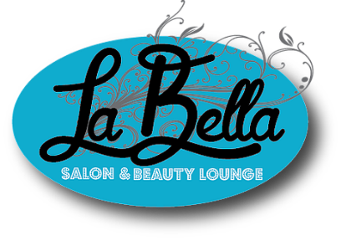

MINOR CONSENT
Minors are permitted to receive massages, facials, manicures & pedicures at La Bella Salon & Beauty Lounge.
Facials, Manicures & Pedicures:
- Minors under the age of 17 must have a parent or legal guardian present to sign and help complete the Guest Intake Form for the minor. The technician will collaborate with the consenting adult and minor to establish goals for the session.
Massage:
- Minors under the age of 18, unless otherwise emancipated, must have a parent or legal guardian present to sign and help complete the Guest Intake Form for the minor. The massage therapist will collaborate with the consenting adult and minor to establish goals for the session.
- Clients age 14 and under, the parent/legal guardian must always be present in the treatment room.
- Clients age 15-17, if both client and parent/legal guardian are comfortable with the minor being in the session room by themselves, please initial here. _____

I, , am the parent/legal guardian of . I have read the above information and give permission for my child to receive massage therapy, facials, manicures, and/or pedicures.

Parent/Legal Guardian Signature:
Date:

Witness Signature:
Date:

